
FLIGHT PRICE PREDICTION PROJECT

Submitted By:
Lakshmi Rajendra Thute

ACKNOWLEDGEMENT
I am very much Thankful to FlipRobo Technologies for giving me the opportunity to work with them and to work on this project and also, I am very grateful to Data Trained Education Team for their support and help to understand each and every concept of machine learning which helped me a lot while working on this project. I thought, I am fortunate to become a part of FlipRobo Technology.

References:
Google website
Stack overflow
Analytics Vidya
Medium
Data trained notes

INTRODUCTION

Anyone who has booked a flight ticket knows how unexpectedly the prices vary. The cheapest available ticket on a given flight gets more and less expensive over time. This usually happens as an attempt to maximize revenue based on - 1. Time of purchase patterns (making sure last-minute purchases are expensive) 2. Keeping the flight as full as they want it (raising prices on a flight which is filling up in order to reduce sales and hold back inventory for those expensive last-minute expensive purchases) So, you have to work on a project where you collect data of flight fares with other features and work to make a model to predict fares of flights.

ANALYTICAL PROBLEM FRAMING

Firstly, I scrapped the flight data including airline name, date of journey, source, destination, route, departure time, arrival time, duration, total stops and the target variable price using Selenium.

• Mathematical/ Analytical Modelling of the Problem
Here I have done Data Pre-processing, Exploratory Data Analysis, then Encoding and lastly model Building and Evaluation.

• Data Sources and their formats
I got the dataset in CSV format and I read the data in Jupyter Notebook using pandas data frame.

• Data Pre-processing Done
The dataset contains object data type columns, missing values, I have treated them with Label encoding, and with mode imputation.

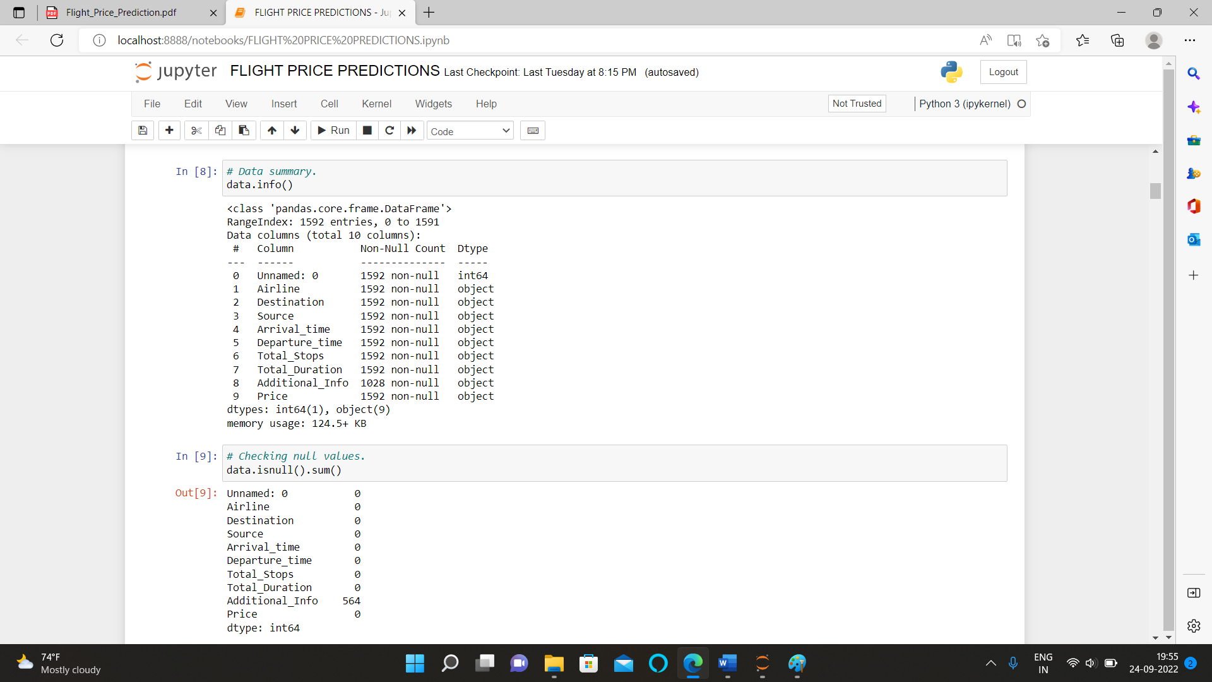

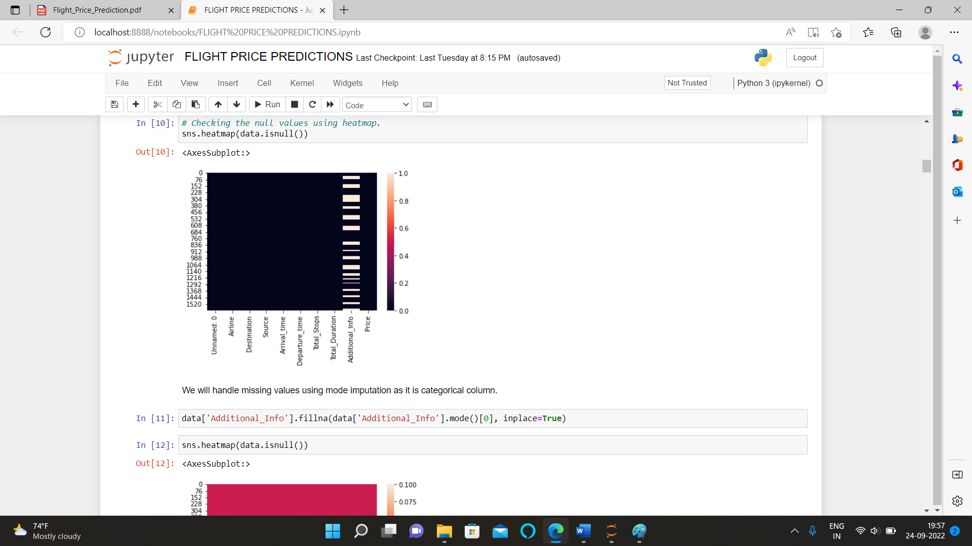

• Hardware and Software Requirements and Tools Used
Here for this project, I used Jupyter notebook and tools used pandas and NumPy for mathematical operations, matplotlib and seaborn for various type of data visualizations

• Identification of possible problem-solving approaches (methods)
The statistical summary shows the total count of 1592 rows then mean, min value, max value, standard deviation and quartiles shows up and down values that means the data contains outliers.

• Testing of Identified Approaches (Algorithms)
- Linear Regression
- Random Forest Regressor
- Support Vector Regressor
- Gradient Boosting Regressor
- Decision Tree Regressor
- KNNeighbors Regressors

- Run and evaluate selected models
Linear regression algorithm shows a linear relationship between a dependent (y) and one or more independent (y) variables, hence called as linear regression. Since linear regression shows the linear relationship, which means it finds how the value of the dependent variable is changing according to the value of the independent variable.

Random Forest is a popular machine learning algorithm that belongs to the supervised learning technique. It can be used for both Classification and Regression problems in ML. It is based on the concept of ensemble learning, which is a process of combining multiple classifiers to solve a complex problem and to improve the performance of the model.

Gradient Boosting Regression is an analytical technique that is designed to explore the relationship between two or more variables (X, and Y).

Support Vector Regression as the name suggests is a regression algorithm that supports both linear and non-linear regressions.

The decision tree regressor is defined as the decision tree which works for the regression problem, where the ‘y’ is a continuous value.

KNN utilizes the entire dataset. Based on k neighbours value and distance calculation method (Makowski, Euclidean, etc.), the model predicts the elements. The KNN regressor uses a mean or median value of k neighbors to predict the target element.

• Key Metrics for success in solving problem under consideration
A company's units can use these dashboards to create milestones and monitor their progress by tracking all the most relevant metrics in one location.

• Visualizations
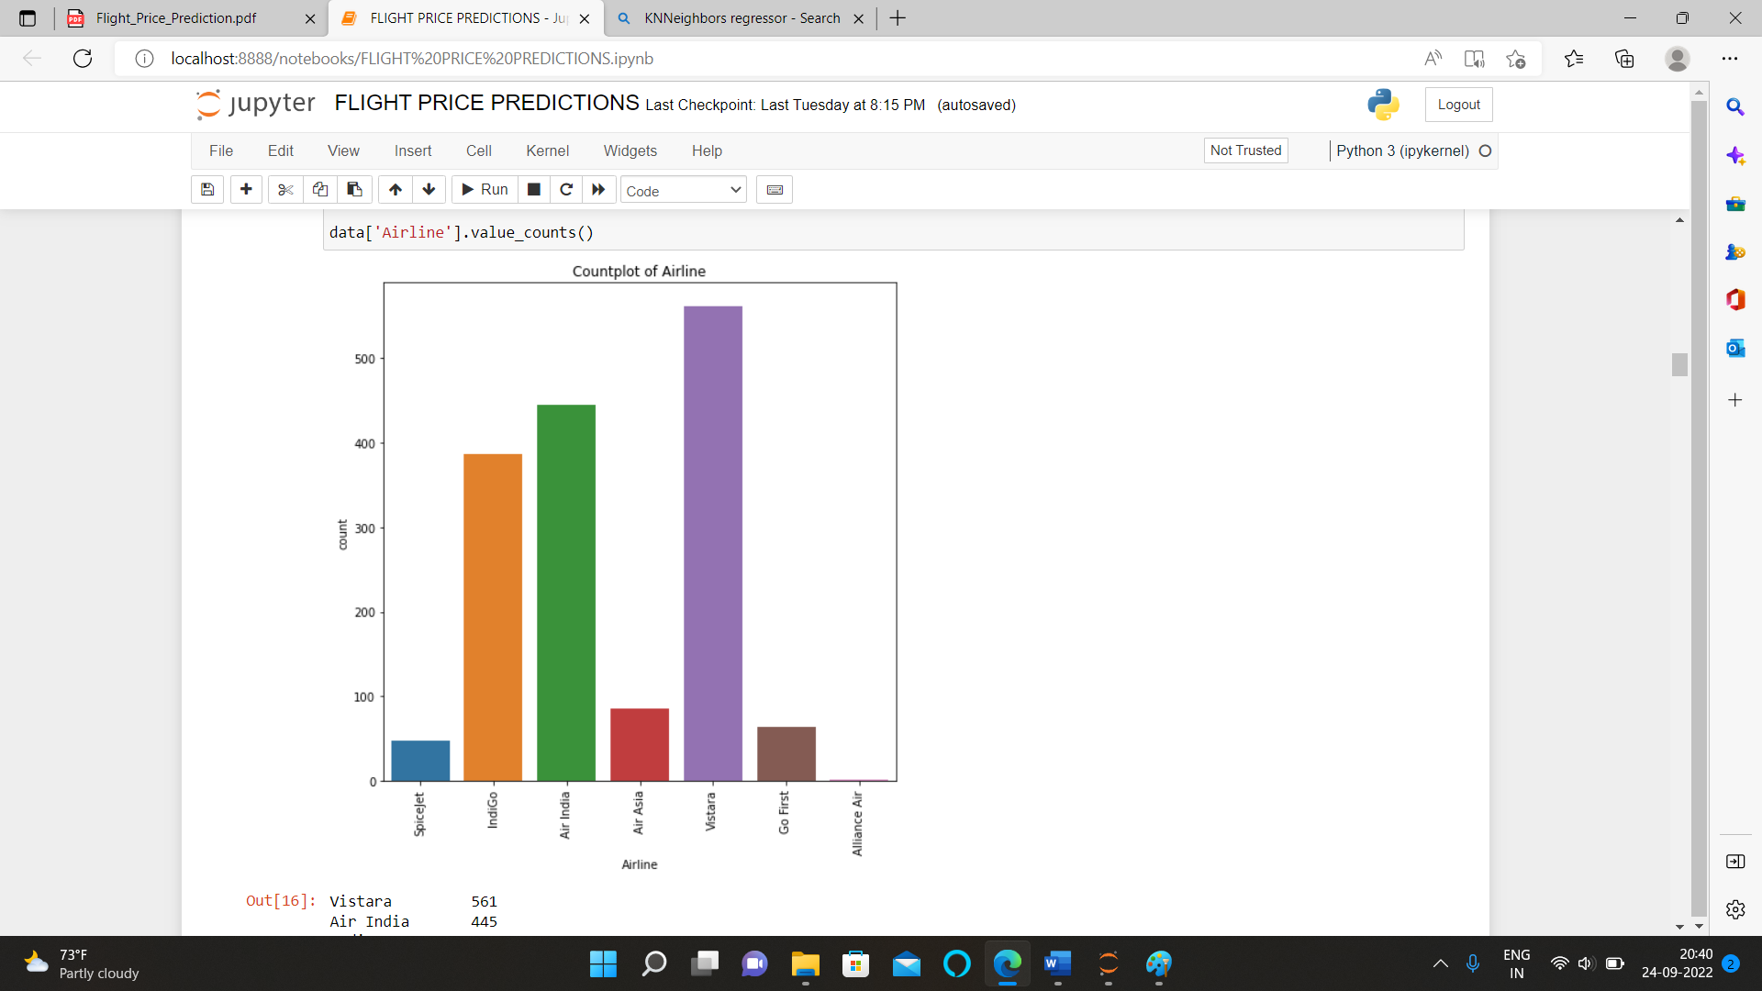

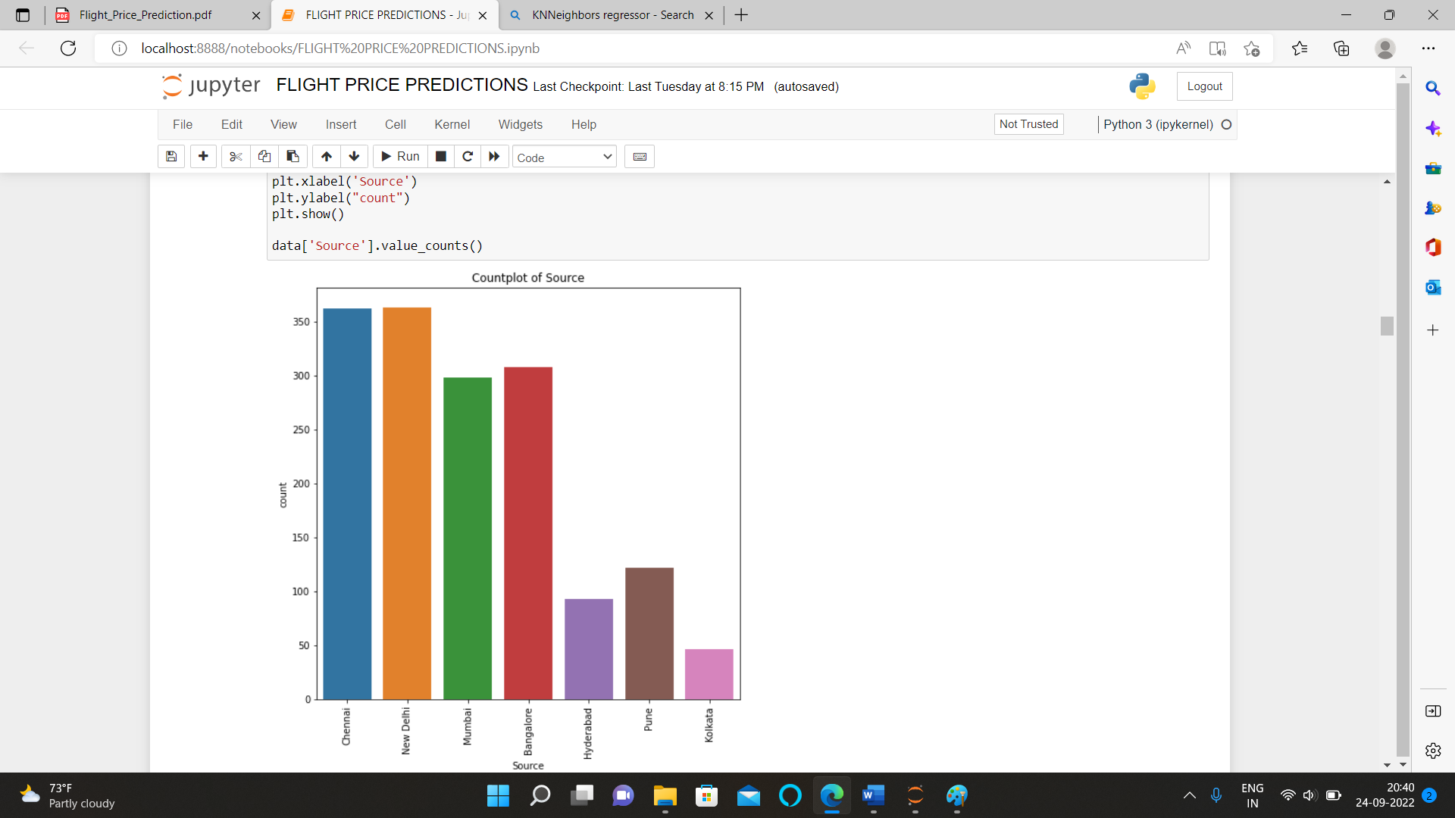

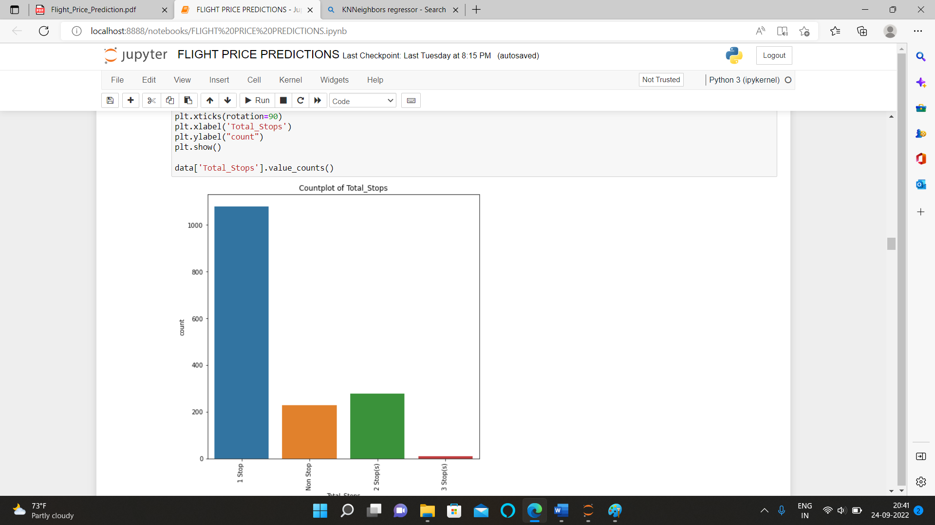

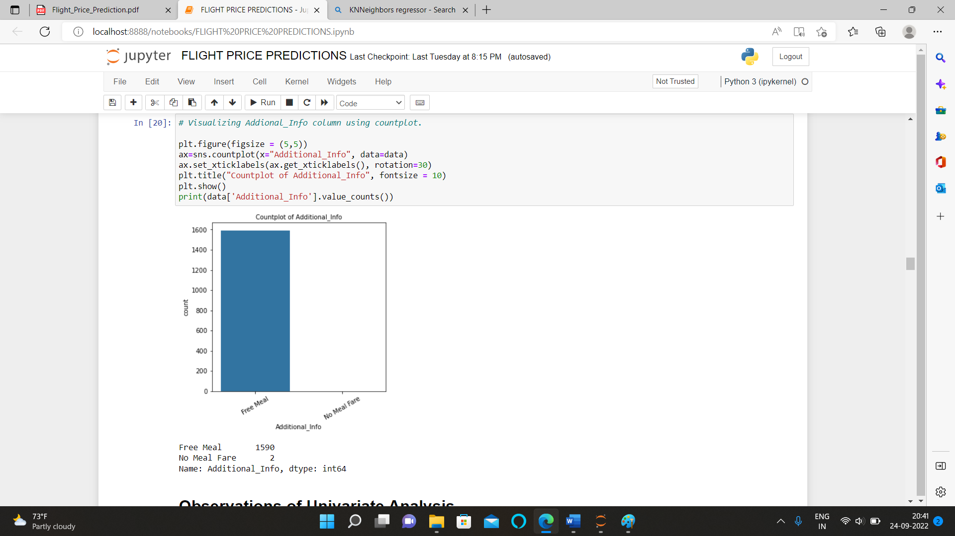

Observations

1.Most of the Airline that flies belong to Vistara and very less are of Alliance air.
2.Most of the flights took off from New Delhi and Chennai and very less from Kolkata.
3.Most of the flights reached to Goa and Kolkata and very less to Pune.
4.Most of the flights only take 1 stop and very less 3 stops.

• Interpretation of the Results
Here after pre-processing we get the data encoded for framing the model and after visualization, we observe that the data contains skewness and we removed it using power transformation (yeo-john method), After checking correlation, we observe that the dataset don’t contain multicollinearity. After data pre-processing and EDA we build 6 different algorithms for dataset and from them Random Forest Regressor algorithm perform very well , Lastly we perform hyper parameter tunning to enhance the r2 score. Here we finalise the Random Forest Regressor algorithm as our best fit model.

